Subject Name: **Source Code Management**

Subject Code: **22CS003**

Session: **2024-25**

Department: **DCSE**



|  |  |  |
| --- | --- | --- |
| **Submitted By:**  YASH  2310992405-First Year  G21git |  | **Submitted To:**  Dr. Chetna kaushal |

**List of Programs**

|  |  |  |
| --- | --- | --- |
| **S. No** | **Program Title** | **Page No.** |
| **1.** | Setting up git clint. | 3-10 |
| **2.** | Setting up GitHub account | 11-13 |
| **3.** | Generate logs | 14-16 |
| **4.** | Create and visualize branches | 17-18 |
| **5.** | Git life cycle description | 19-25 |

**Experiment No. 01**

**Aim:** Write step-by-step procedure for setting up Git Client

**Algorithm:**

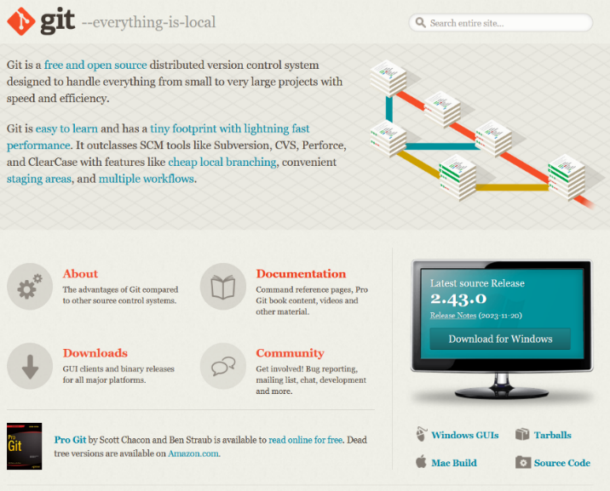1. Go to the website and download Git v2.43.0

2. Run the setup.

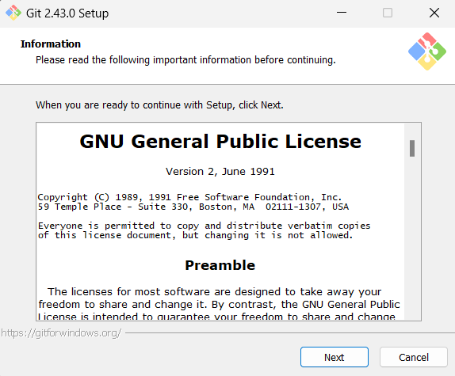

3.Select destination location.

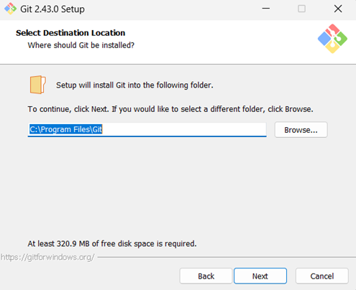

4.Select components to be installed

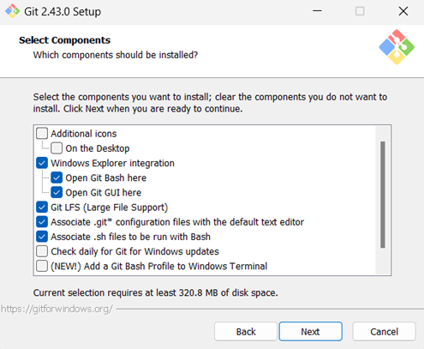

5.Select start menu folder.

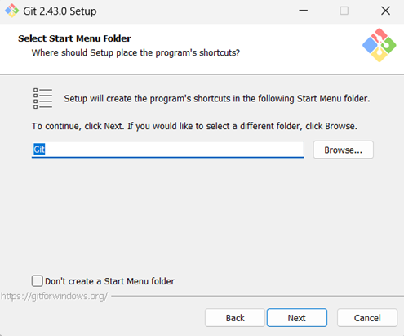

6. Coose the default editor used by git.

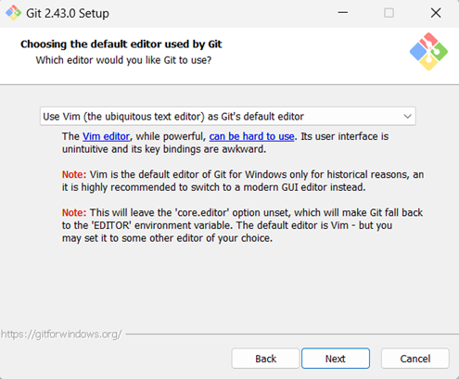

7.Adjust the name of initial branch in new repository .

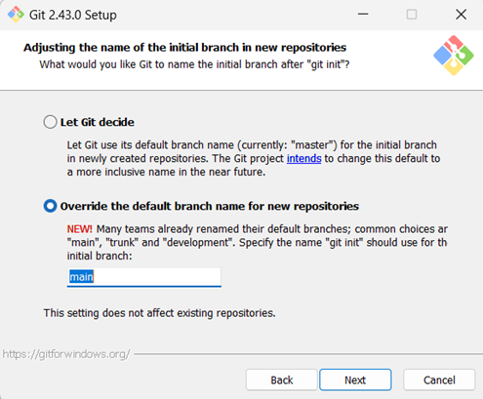

8. Adjust the path environment.

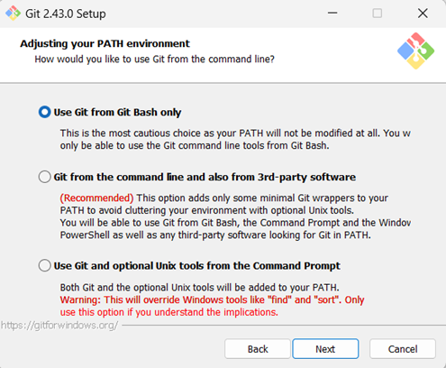

9. Choose the option “Use bundled OpenSSH”.

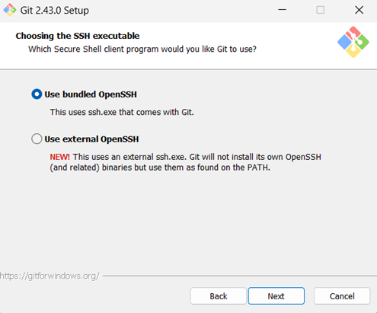

10. Choose the option OpenSSL library.

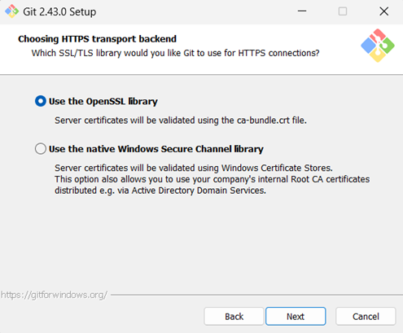

11. Choose option “Use MinTTY”.

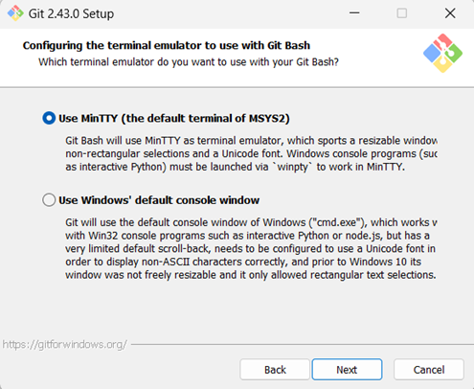

12. Choose the option “Fast-forward or merge”.

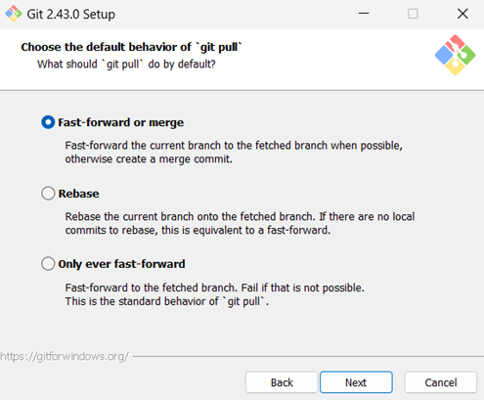

13. Choose option “Checkout Windows style, commit Unix-Style line endings”.

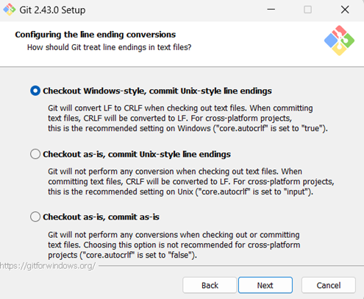

14.Choose option “Enable file system caching”.

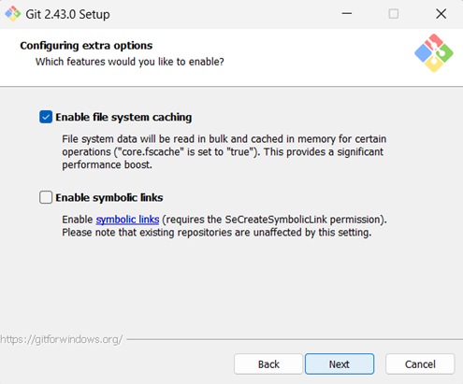

15. Click on “Intsall” button.

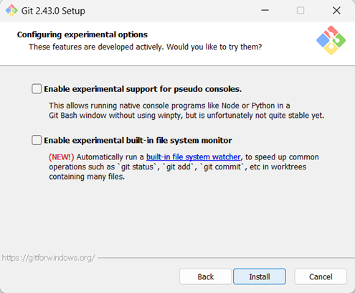

16. Select option “Git Credential Manager”.

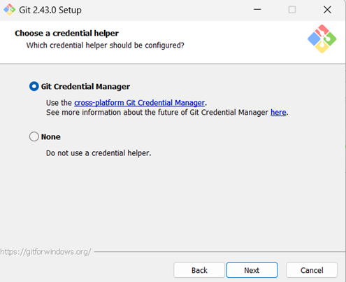

17. Finish the setup.

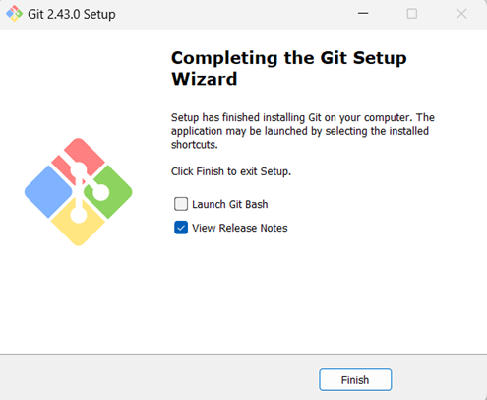

18. The Git will start installing.

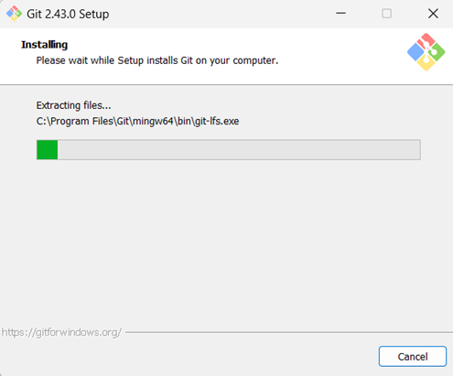

19. Checking git version.

$git –version

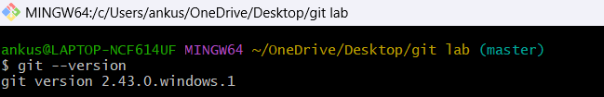

20. Setting up username and mail.

$git config --global user.name “Yuvrajput”

$git config –global user.mail “yuvrajchauhan382@gmail.com”

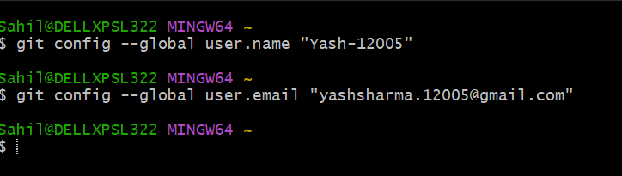

**Experiment No. 02**

**Aim:** Write a procedure for setting up GitHub Account.

**Algorithm:**

1. Go to the github.com and start signing up for a github account.



2. Enter your mail and create username and password.

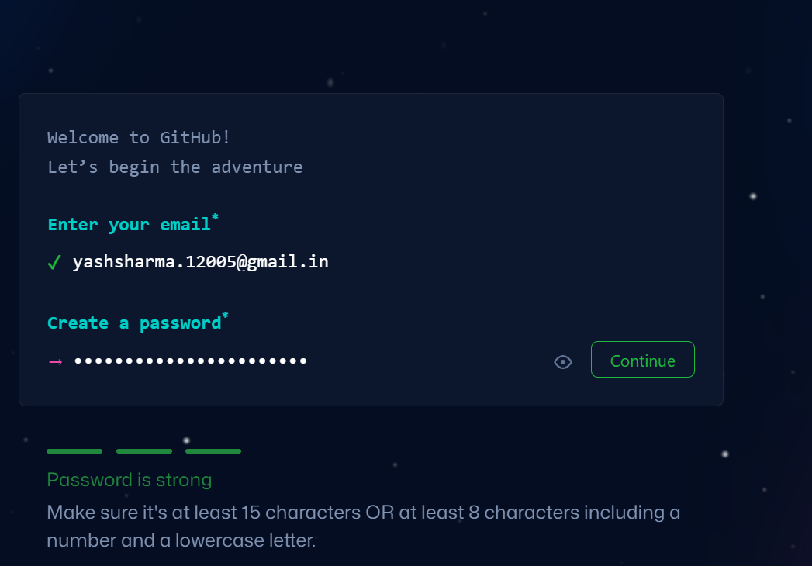

3. Complete the verification.

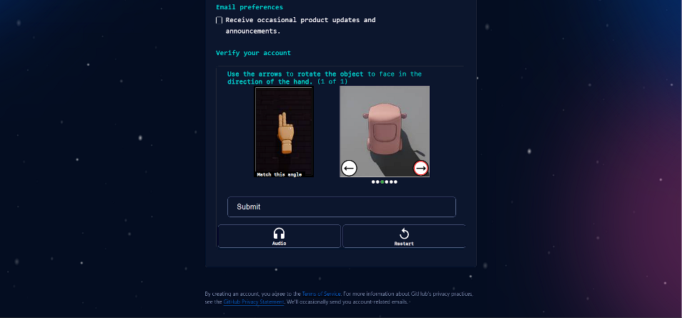

4. Git hub account will be created and we will be directed towards dashboard.

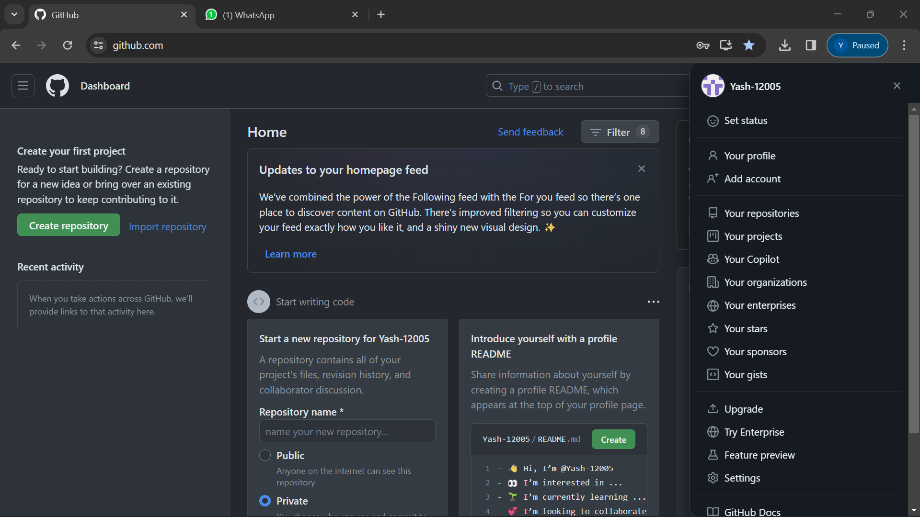

5. Now create a new public repository.



6. After adding name click on “Create Repository”.

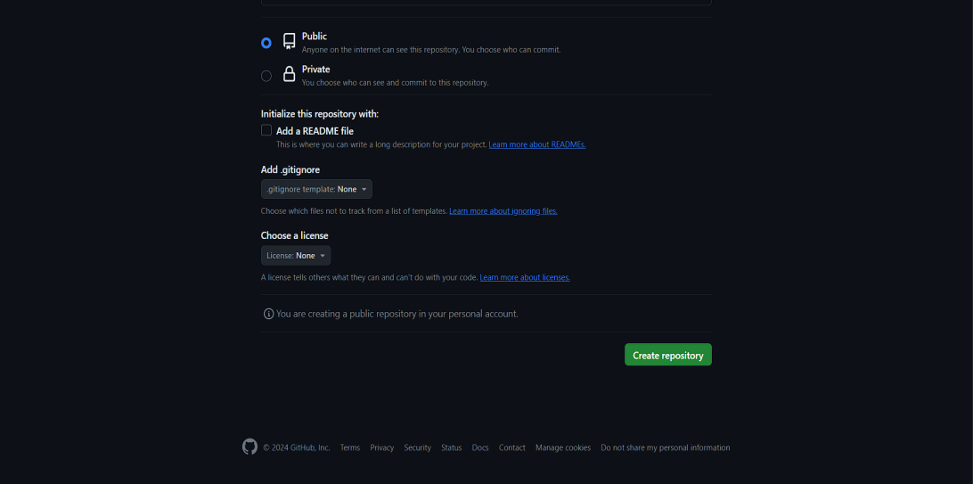

7. Now we will see out empty repository.

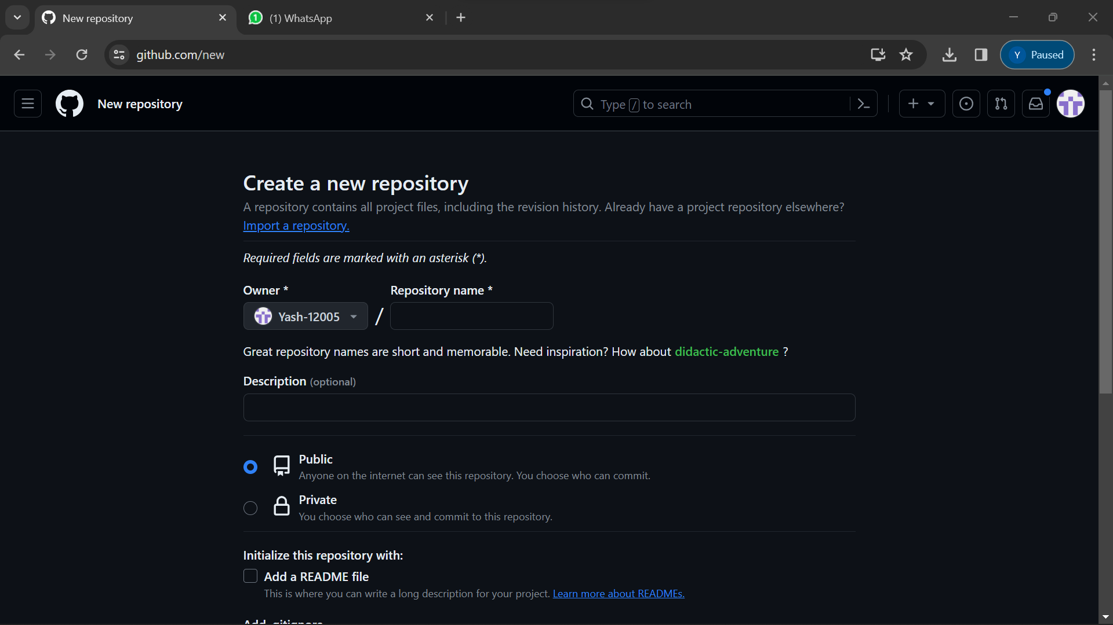

8. Create a new text file in repository as shown.

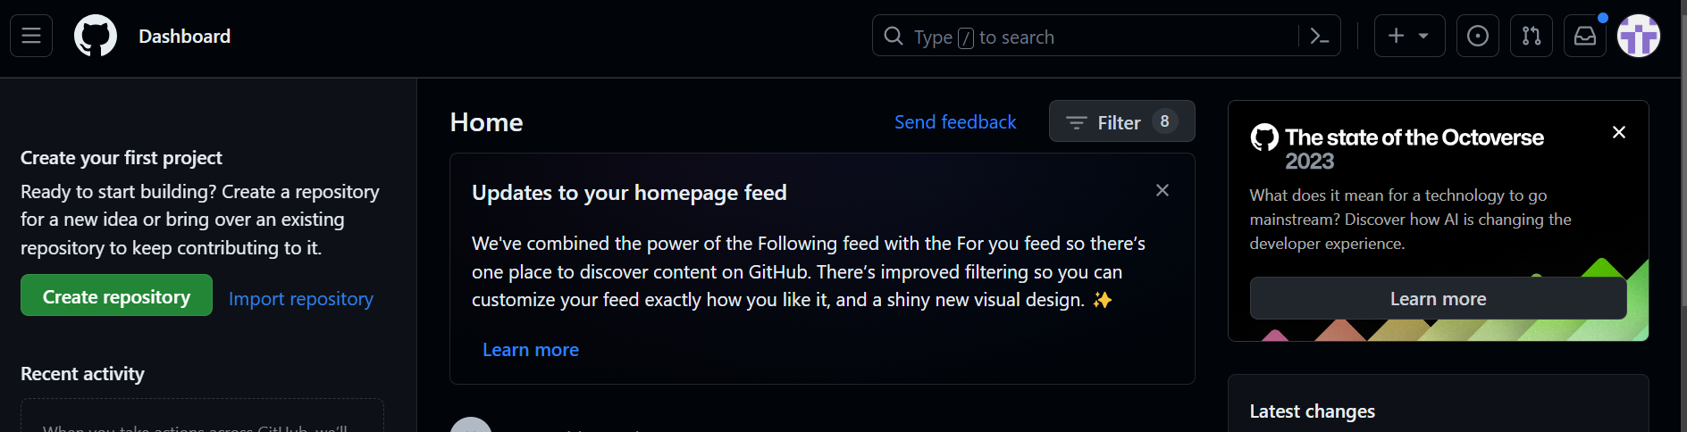

9. We will be able to see that file under our repository.

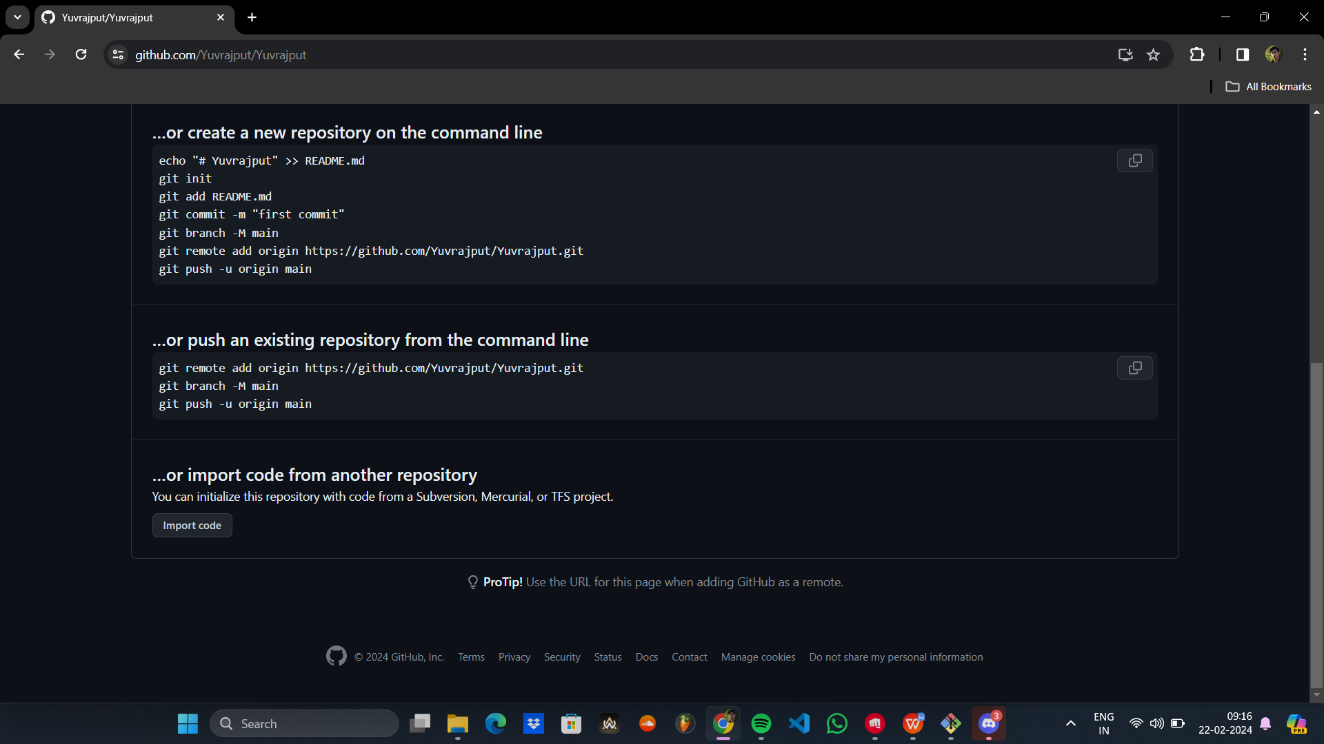

10. Copy file in repository to a folder in device by using link of that file.

$ git clone <https://github.com/aroraankush10/SCM-1.git>

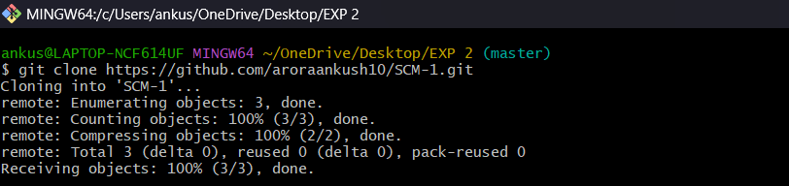

**Experiment No. 03**

**Aim:**  Write step-by-step procedure to generate logs in git.

**Algorithm:**

**1.** Git initialization, adding and committing.

$touch sampleFile.txt

$git init

$git add .

$git status

$git commit -m “Initial Commit”

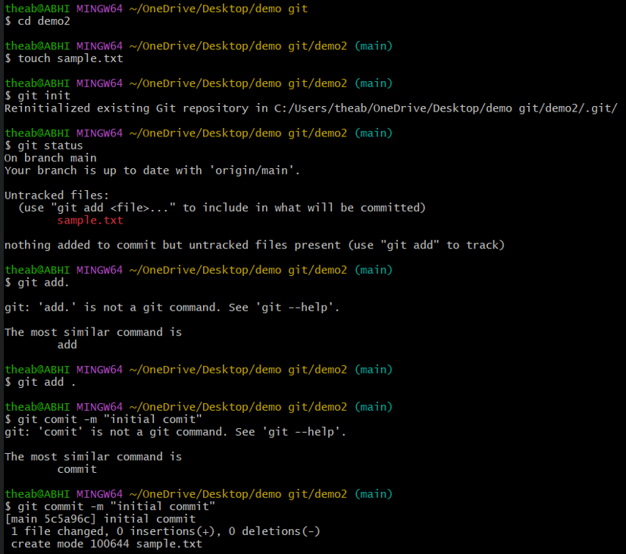

2. Checking state of working directory.

$git status

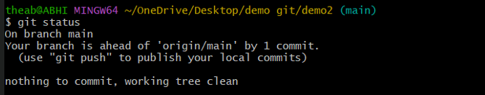

3. Getting changes made in file.

$git log

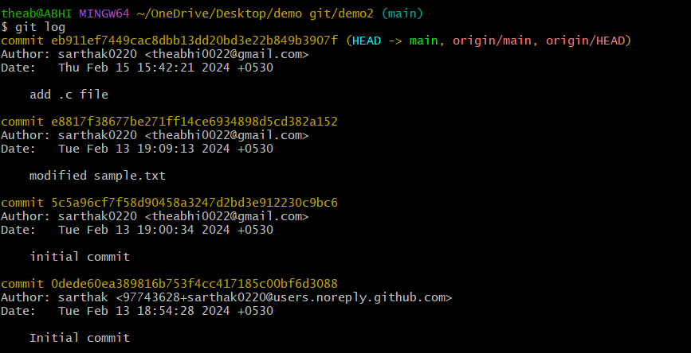

4. Displaying commit.

$git log --oneline

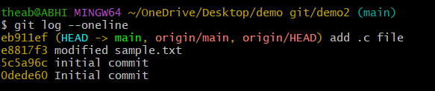

5. Displaying changes made in file.

$git log --stat

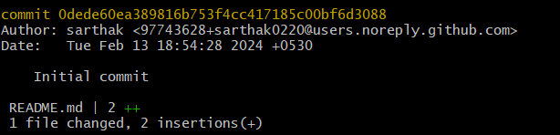

6. Getting content of file.

$git blame sampleFile.txt

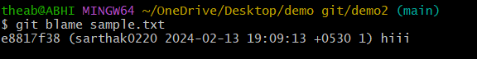

7. Getting details of the Git objects

$git show

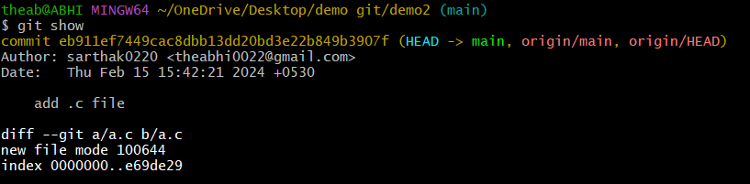

8.

$git diff

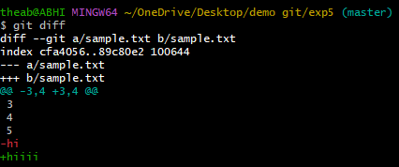

9. Finally use the following commands.

$git status

$git add .

$git commit -m “Modified sampleFile.txt”

$git status

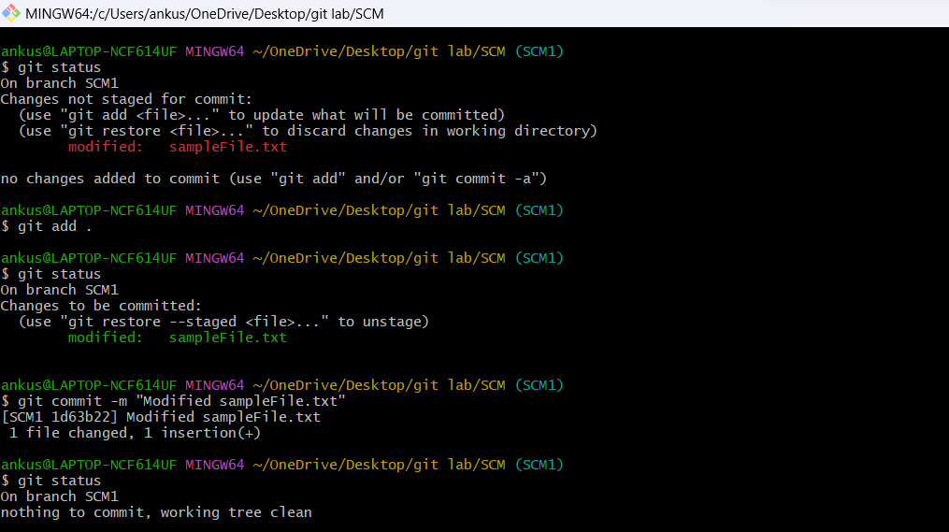

**Experiment No. 04**

**Aim:** Create and visualise branches on Git Clint.

**Algorithm:**

1. Create new branch.

$git branch newbranch



2. To check how many branches we have.

$git branch

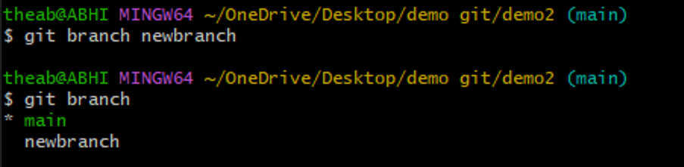

3. To change current working branch.

$git checkout master

$git switch newbranch

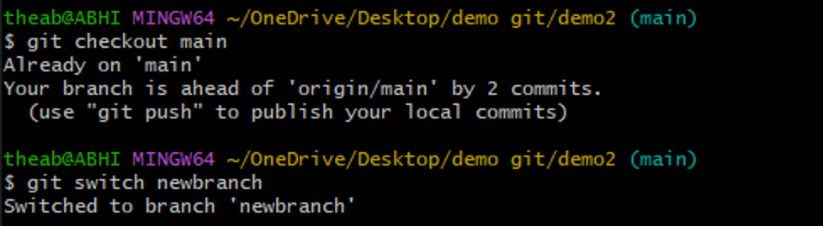

4. Visualising branches:- Create a new file and using above process create a new branch with name “newbranch”. Create two files in that folder named index.html and text.txt.

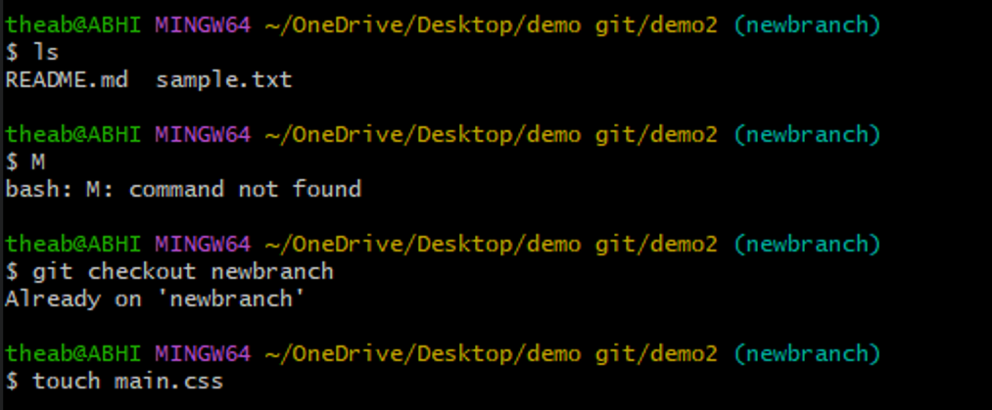

5. Now that we have successfully created and committed a new

file in the new branch.

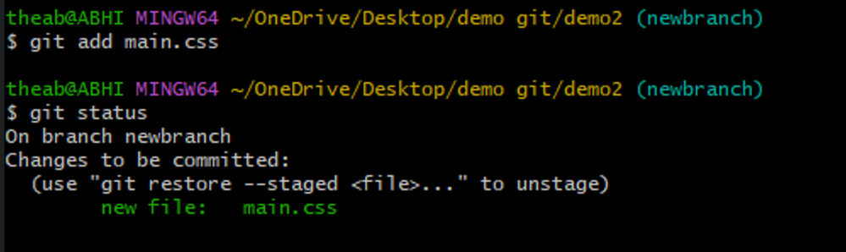

6. Switch back to the main branch.

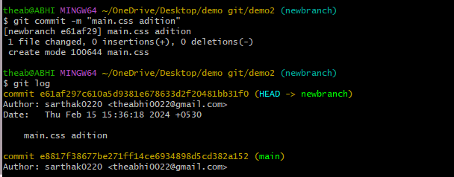

7. And here it is we can access the main.css file when we use

the newbranch branch but not in master branch because the

origin of main.css file is from newbranch branch.

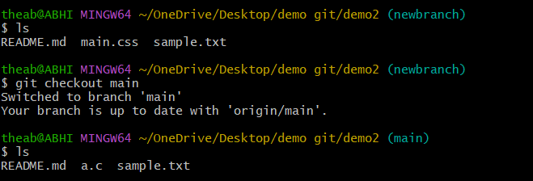

**Experiment No. 05**

**Aim:** Write a description of the key stages in a git lifecycle.

**Algorithm:**

1. Create a Folder.

2. Right click on Folder and click “Open Git Bash Here 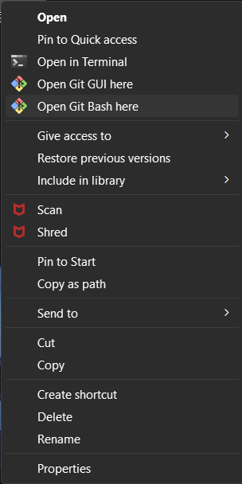

3. Create a File inside Folder.

$touch sampleFile.txt



4. Git Initialization

$git init



5. Check Git Status

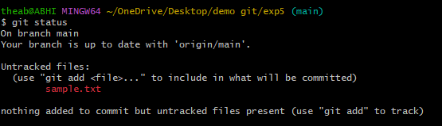

6. Add a simple created File to staging area.

$git add sampleFile.txt

$git status

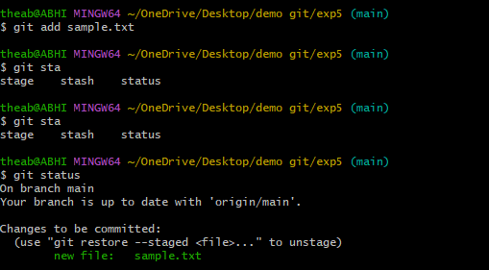

7. Create multiple new Files and check status.

$touch new1.txt

$touch new2.txt

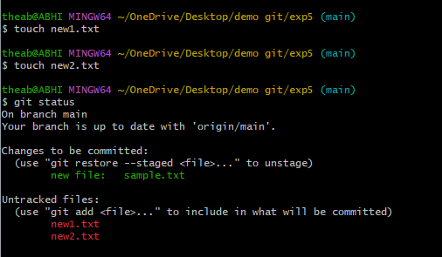

8. Add multiple Files to staging area.

$git add .

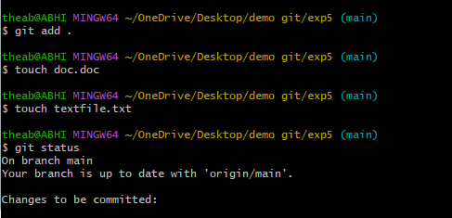

9. Create multiple files with different extensions.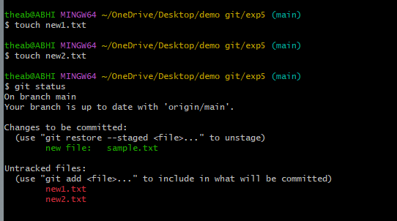

10. Add multiple files of different extensions to the staging area.

$git add . or $git add -A

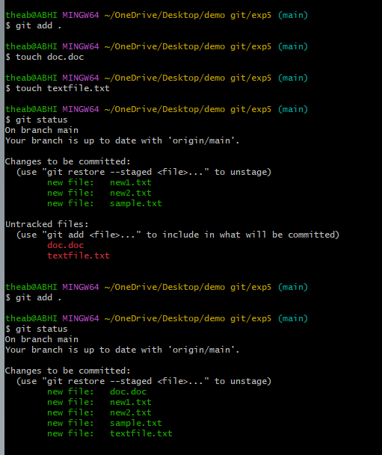

11. Remove Files from the Directory and check status.

$git rm –cached<filename.extension>

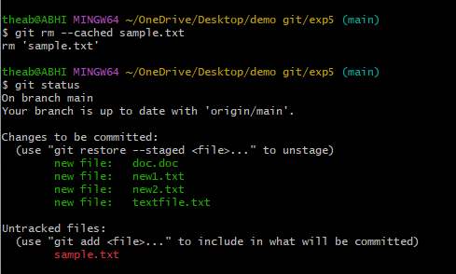

12. Commit

$git commit“Commit Message”

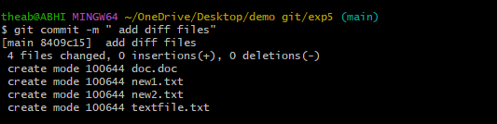

13. Check Git status.

$git status

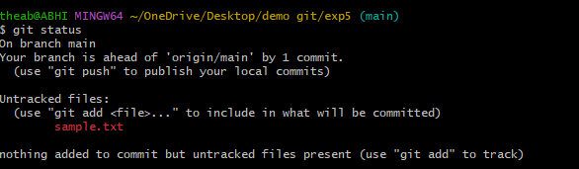

14. Modify File contents.



15. Add the Modified file to staging area.

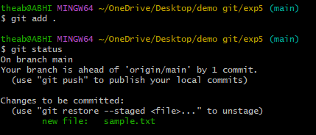

16. Commit.

